[](http://www.google.com/url?sa=i&rct=j&q=&esrc=s&source=images&cd=&cad=rja&uact=8&ved=0ahUKEwjCl4-AuMvOAhXGMSYKHeR2Cd0QjRwIBw&url=http://www.clipartpanda.com/categories/college-clip-art&bvm=bv.129759880,d.dmo&psig=AFQjCNHANl9wdTjIIDtHDvnaGqLIzfekWg&ust=1471625905969261)[](http://www.google.com/url?sa=i&rct=j&q=&esrc=s&source=images&cd=&cad=rja&uact=8&ved=0ahUKEwjPoc2_mMvOAhVDRiYKHQHDBzMQjRwIBw&url=http://www.mhprep.com/jupiter-grades.html&psig=AFQjCNFSh77eCtJBcejXUlFOXxUJ60NVLg&ust=1471617485095726)

4

Fill out the FAFSA

Begin October 1st



Adapted from WWW.AIE.ORG/8STEPS

**5**

Explore Scholarships!

[](http://studyabroadarkansas.blogspot.com/2016/03/five-study-abroad-scholarships-still.html)

**6**

Apply to college!

(not just 1)

4 year, 2 year, or technical

# **8 Steps to College**

**R U Ready?**

**8**

Enroll in the college of your choice!

**7**

*Get letters of recommendations*

Teachers

Professors

Employers

Club advisors

Counselor

**3**

Take entrance exam:

[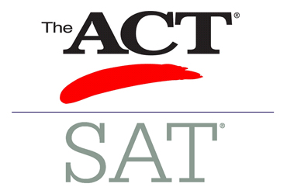](https://www.google.com/url?sa=i&rct=j&q=&esrc=s&source=images&cd=&cad=rja&uact=8&ved=0ahUKEwiY74L2n8vOAhVHOCYKHYymD2AQjRwIBw&url=https://www.beaverton.k12.or.us/schools/sunset/academics/college-careers/Pages/SAT-ACT-PSAT-Testing.aspx&bvm=bv.129759880,d.dmo&psig=AFQjCNH-g-Nj98BViOarhnjcySuevRXJxQ&ust=1471619348680460)

**2**

Get good grades!

**1**

Make up your mind to go to college

